School of Computer Science and Artificial Intelligence

Lab Assignment # 6.5

Program : B. Tech (CSE)
Specialization : -
Course Title : AI Assisted Coding
Course Code : 23CS002PC304
Semester : II
Academic Session : 2025-2026
Name of Student : Yeshwanth
Enrollment No. : 2403A51L39
Batch No. : 52
Date : 23/01/26

Submission Starts here

Screenshots:
Task Description #1 (AI-Based Code Completion for Conditional
Eligibility Check)
Task: Use an AI tool to generate eligibility logic.

Prompt:
give a python program to check voting eligibility based on age and citizenship

Code:

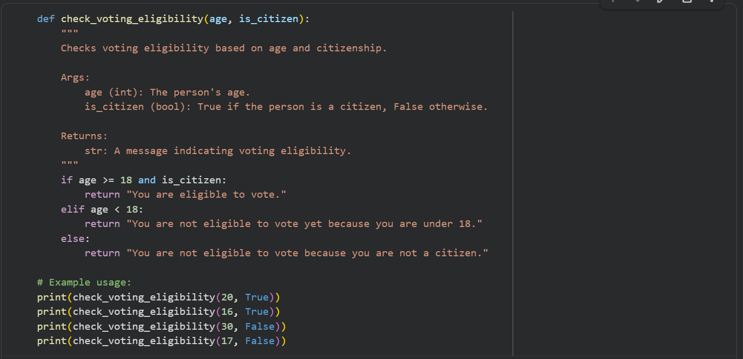

Output:
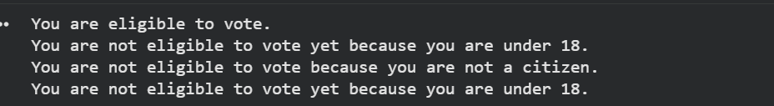

Explaination:
1.if age >= 18 and is_citizen:

This is the primary condition for eligibility. A person is eligible to vote if both their age is 18 or greater, and they are a citizen (meaning is_citizen is True).
If both these parts are true, the function returns: "You are eligible to vote."

2.elif age < 18:
This condition is checked only if the first if condition was false. It specifically checks if the person's age is less than 18.
If this is true, it means the person is too young to vote, regardless of citizenship. The function returns: "You are not eligible to vote yet because you are under 18."

3.else:
This else block is reached only if both the if and elif conditions above were false.
If the first if (age >= 18 and is_citizen) was false, and the second elif (age < 18) was also false, it implies that the person is 18 or older but not a citizen (is_citizen must be False).
In this case, the function returns: "You are not eligible to vote because you are not a citizen."

Task Description #2(AI-Based Code Completion for Loop-Based
String Processing)
Task: Use an AI tool to process strings using loops.

Prompt:
program to count vowels and consonants in a string

Code:
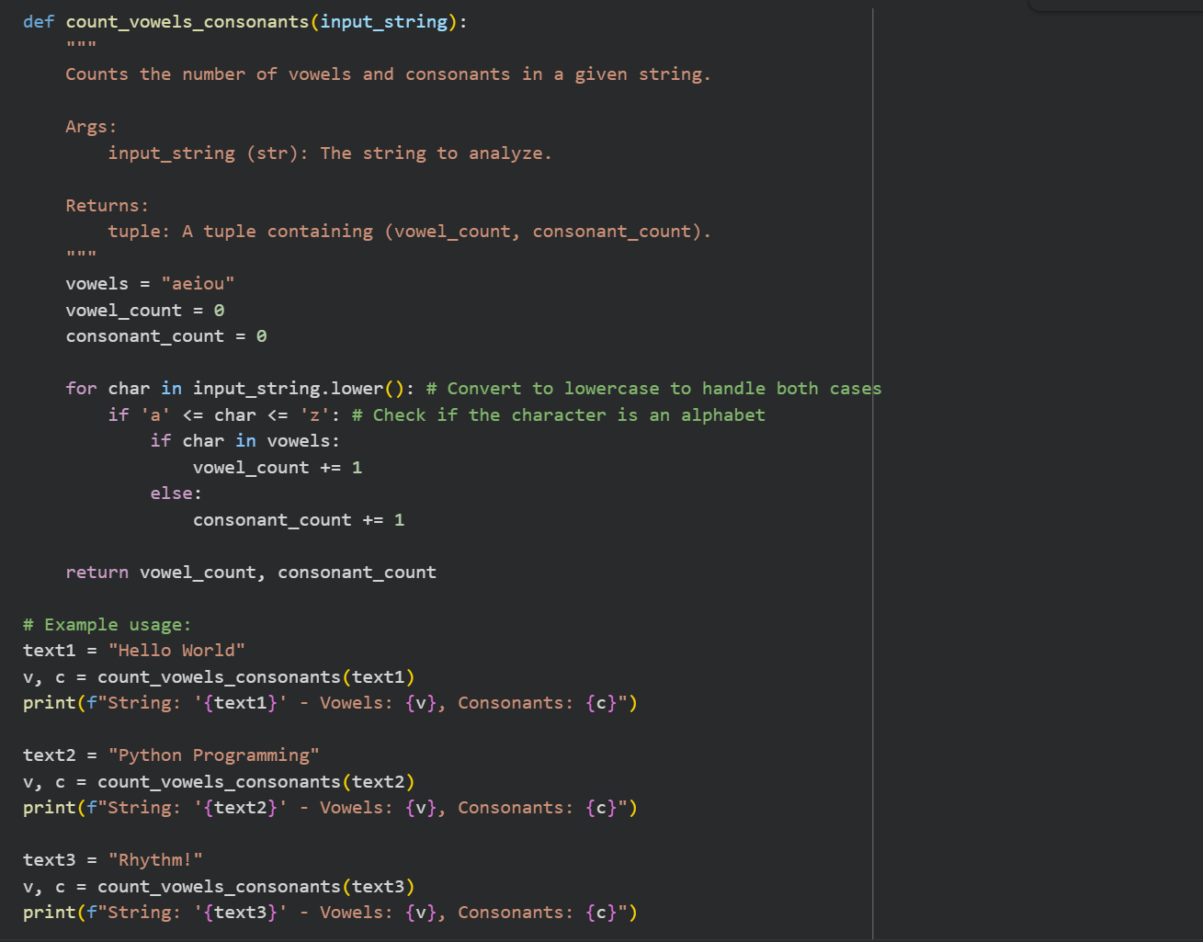

Output:
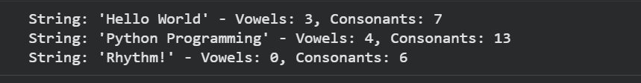

Explaination:
1.Initialization:

vowels = "aeiou": A string vowels is defined to easily check if a character is a vowel.
vowel_count = 0 and consonant_count = 0: Two variables are initialized to zero to keep track of the counts.
2.Lowercase Conversion:

for char in input_string.lower():: The input_string is first converted to lowercase using .lower(). This is crucial because it ensures that the vowel check (char in vowels) works for both 'A' and 'a', 'E' and 'e', and so on, without needing to check for uppercase vowels separately.
3.Character Iteration:

The for loop then iterates through each character (char) of this lowercase string.

4.Alphabet Check:

if 'a' <= char <= 'z':: Inside the loop, the first condition checks if the current char is an alphabet (between 'a' and 'z'). This step is important to ignore non-alphabetic characters like spaces, numbers, or punctuation (e.g., '!', ' ', '1') when counting vowels and consonants.
5.Vowel or Consonant Determination:

if char in vowels:: If the character is indeed an alphabet, this nested if condition checks if the char is present in our vowels string. If it is, vowel_count is incremented.
else:: If the character is an alphabet but not a vowel, it must be a consonant. In this case, consonant_count is incremented.
6.Return Value:

return vowel_count, consonant_count: After iterating through all characters, the function returns a tuple containing the final vowel_count and consonant_count.

Task Description #3 (AI-Assisted Code Completion Reflection
Task)
Task: Use an AI tool to generate a complete program using classes,
loops, and conditionals.

Prompt:
Generate a Python program for a library management system
using classes, loops, and conditional statements.

Code:
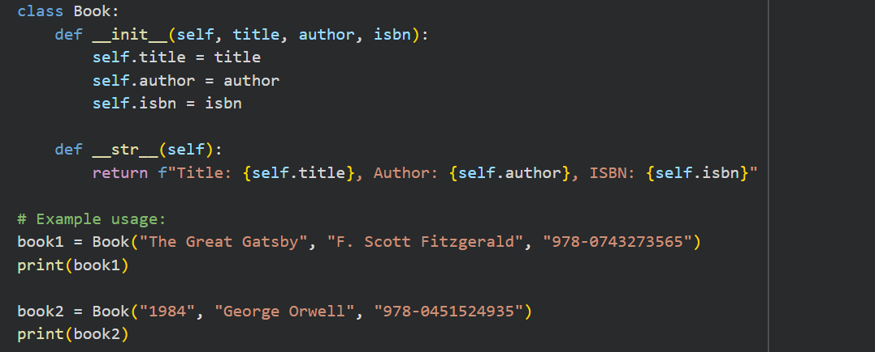

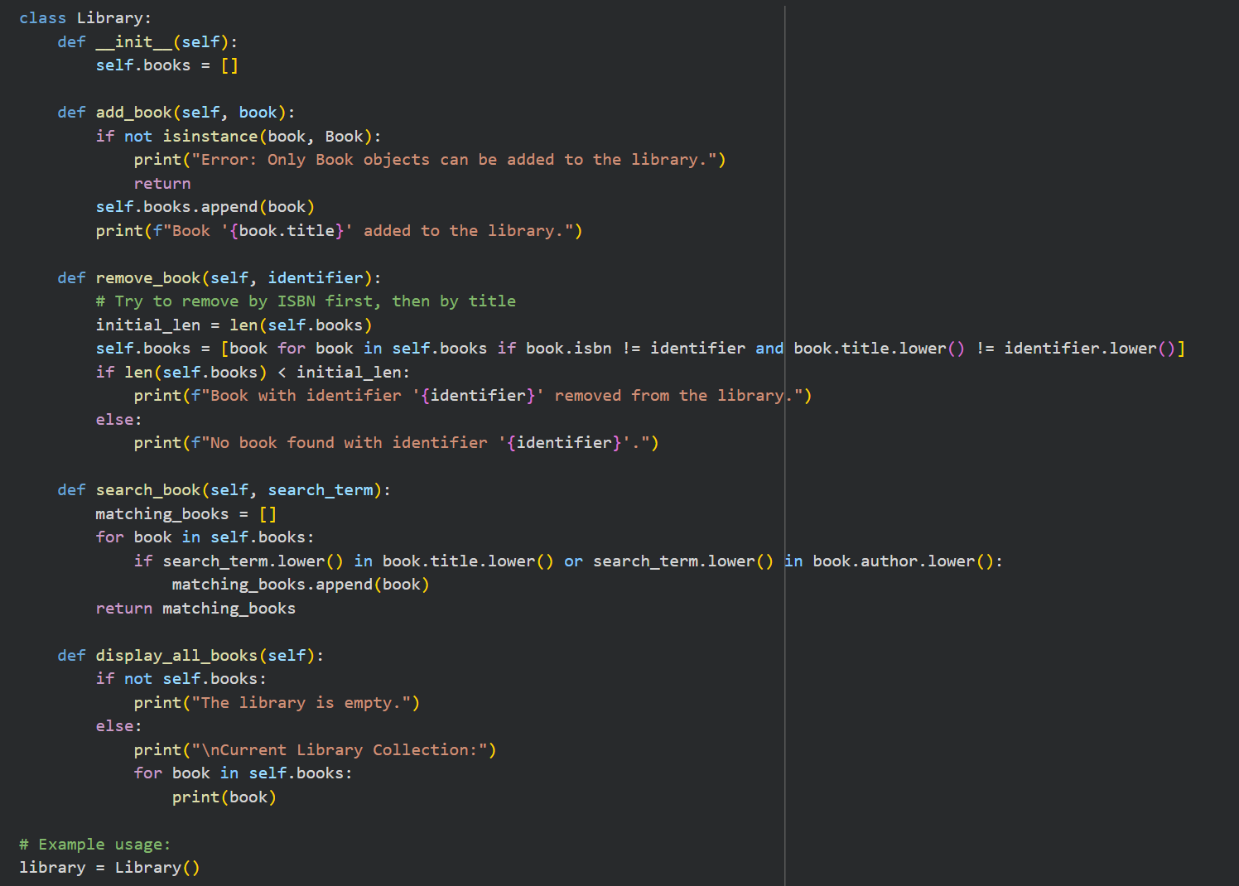
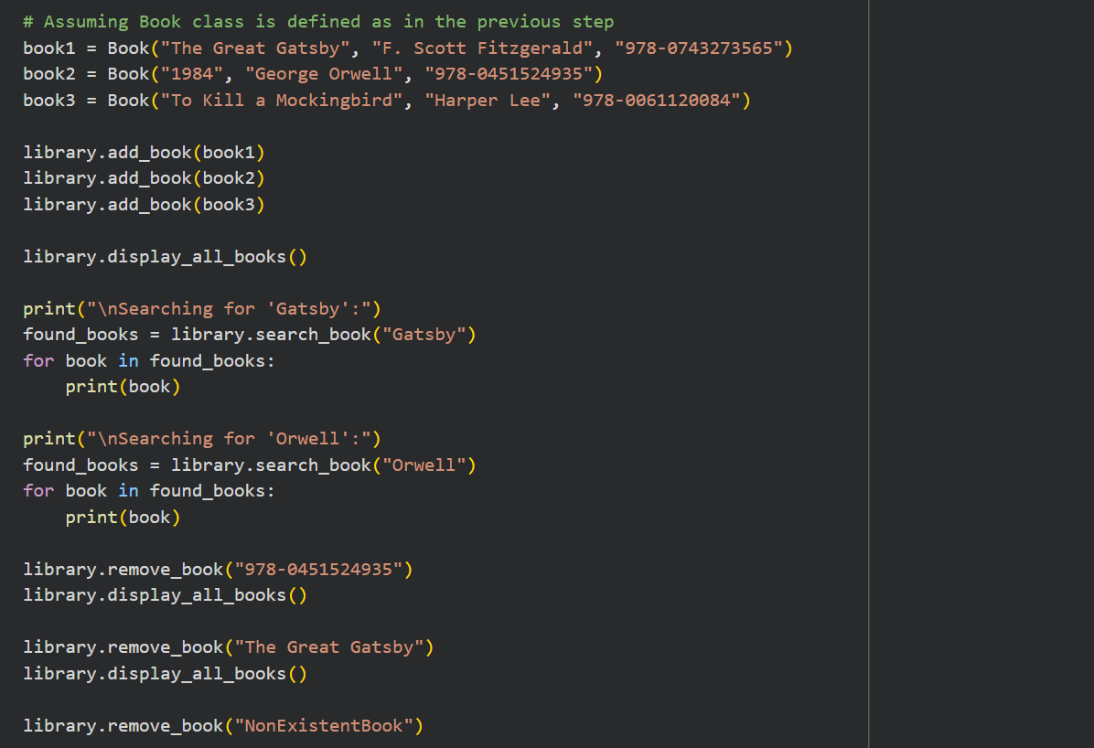

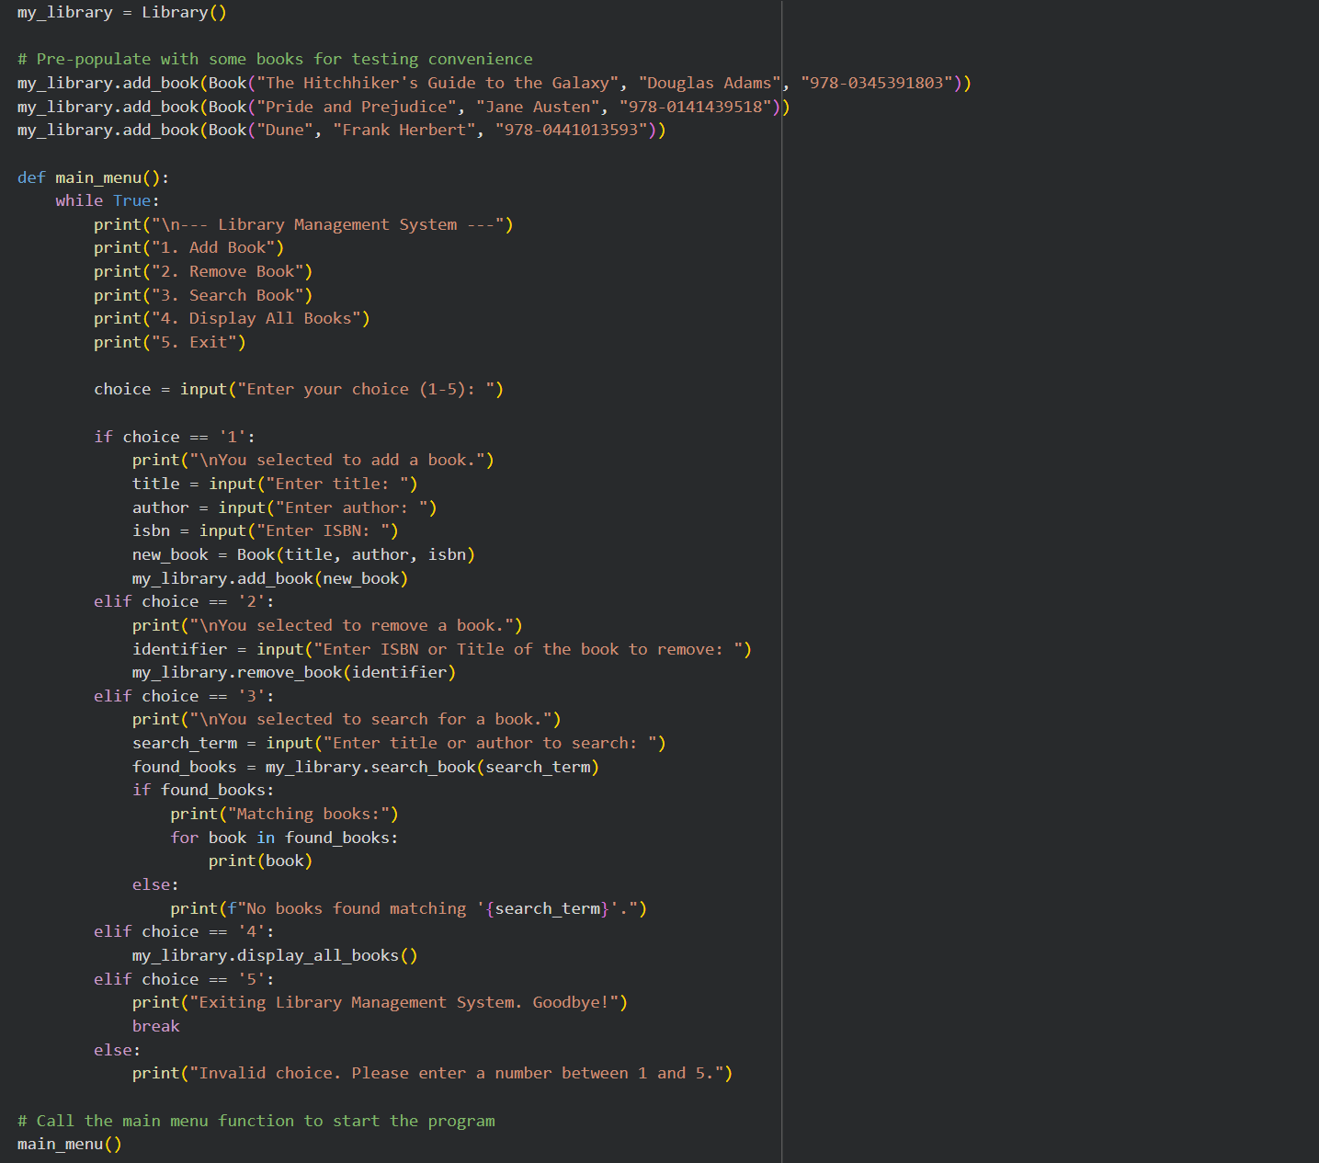

Output:
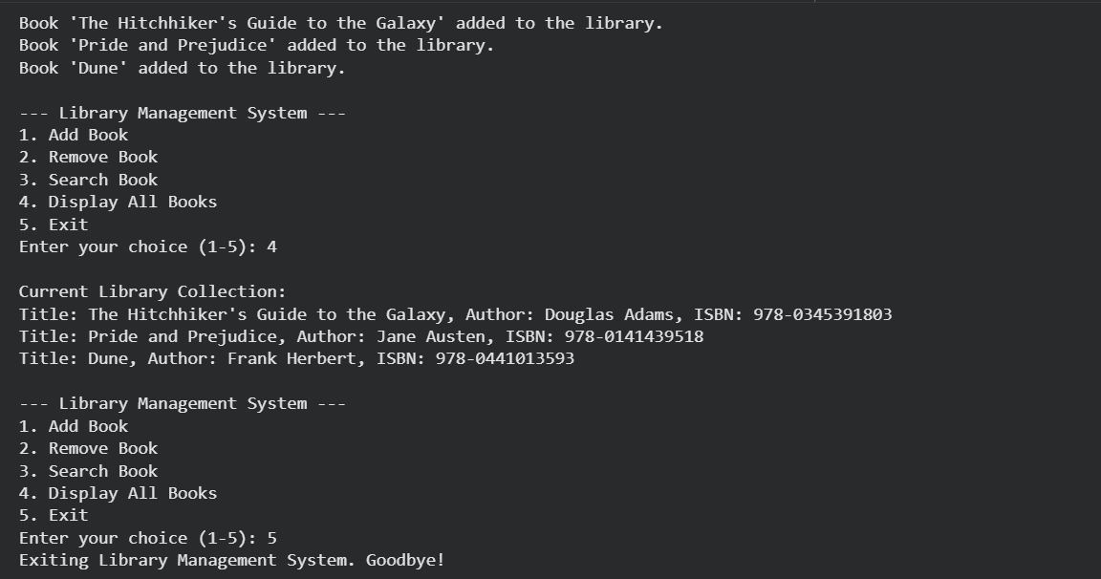

Task Description #4 (AI-Assisted Code Completion for Class-
Based Attendance System)
Task: Use an AI tool to generate an attendance management class.

Prompt:
Generate a Python class to mark and display student
attendance using loops.
Code:
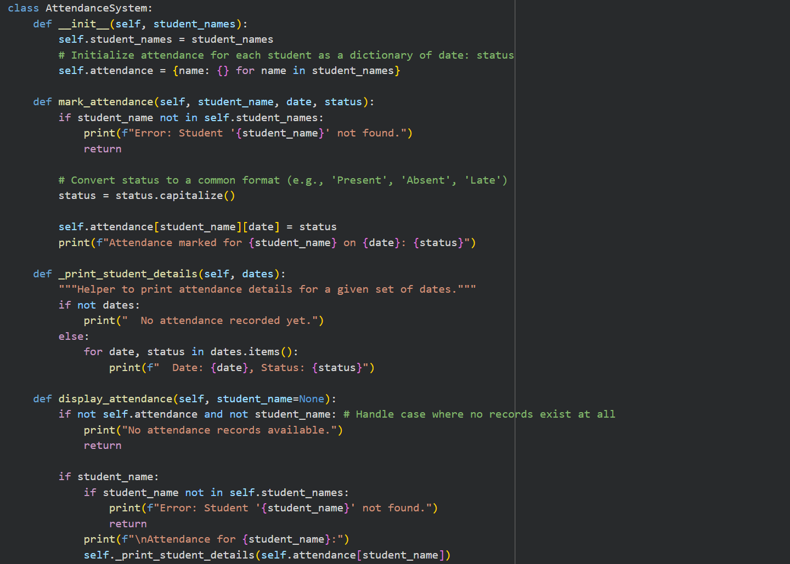
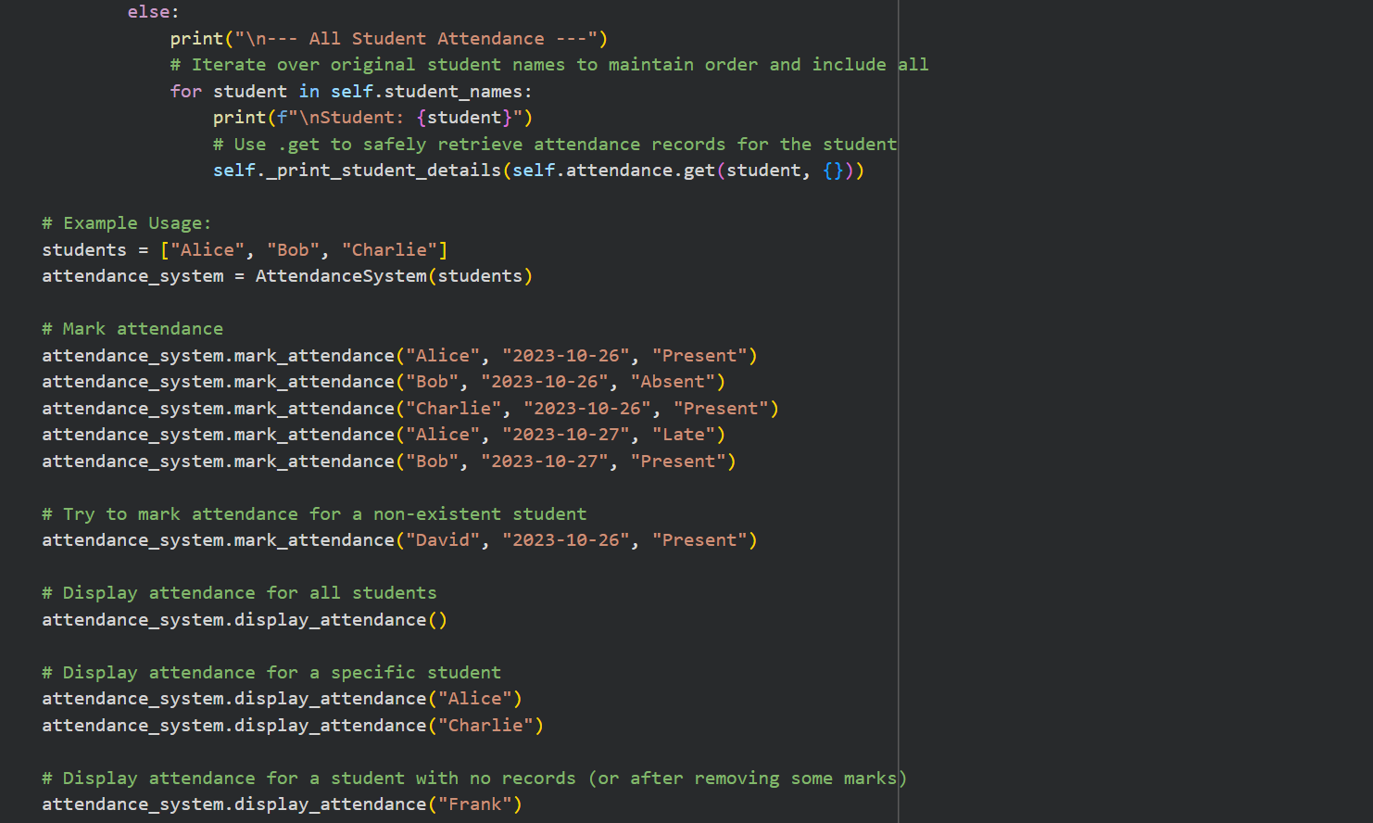

Output:
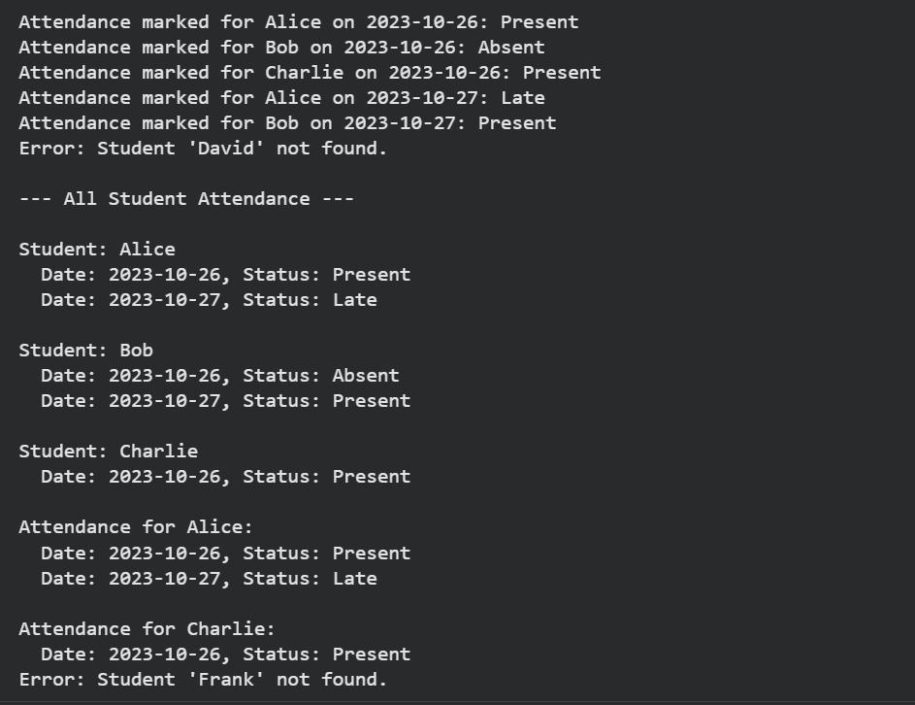

Task Description #5 (AI-Based Code Completion for Conditional
Menu Navigation)
Task: Use an AI tool to complete a navigation menu.

Prompt:
Generate a Python program using loops and conditionals
to simulate an ATM menu.

Code:
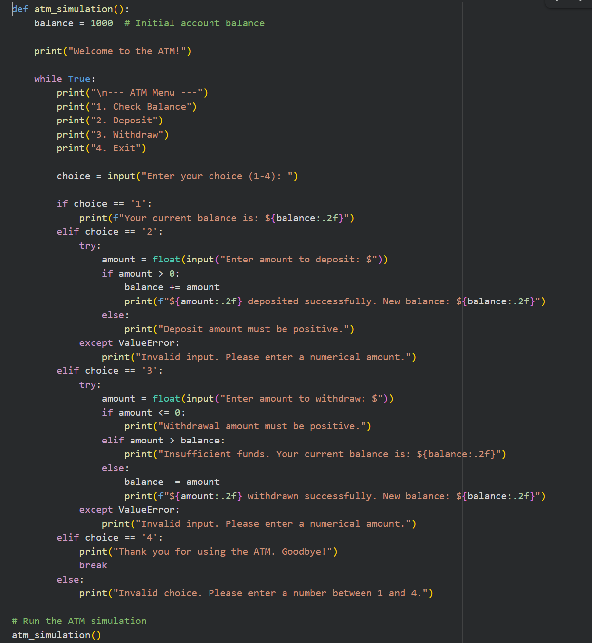

Output:
